Operational Concept Description (OCD)

Project RAP (Rapid Access Pass)

Team 1

Team members and roles
Lizz - Project Manager

Nakul - Software Architect

Ian - Requirements Engineer

Jorge - Feasibility Analyst

Rishi - Operational Concept Engineer

Katherine - Life Cycle Planner

Andrew Borba - Prototyper

09/12/2013

Version History
Date | Author | Version | Changes made | Rationale
08/20/12 | SK | 1.0 | - Original for CSCI477; Tailored from ICSM OCD Template | - To fit CS477 course content
9/12/2013 | Team RAP | 1.1 | - Filled out initial OCD for project | - Document the Project RAP Initiative

Table of Contents
Operational Concept Description (OCD) i
Version History ii
Table of Contents iii
Table of Tables iv
Table of Figures v
1. Shared Vision 1
1.1 Overview of the system 1
1.2 System Boundary and Environment 2
2. System Transformation 4
2.1 System Objectives, Constraints and Priorities 4
2.2 Proposed New Operational Concept 6

Shared Vision

Overview of the system
Key Partners | Key Activities | Value Proposition |  | Customer Relationships | Customer Segments
- LA Metro  - TAP | - Software Design and Development  - Integration with Metro infrastructure  - Marketing of application | - Convenience for customers to purchase and use metro tickets  - Ticket elimination reducing cost and environmental impact  - Technological advancement of public transportation system. |  | - LA Metro  - Apple Appstore  - Android Store  - Windows Phone Marketplace | - Transportation companies.
- LA Metro  - TAP | Key Resources  - PhoneGap API  - Development Team  - NFC Technology  - QR Technology |  |  | Channels  - Application Stores  - LA Metro Website  - Posters and Billboards at stations.
Cost Structure  - Development Team  - Back-End System Administrator |  |  | Revenue Streams  - Flat Fee for project implementation  - Recurring fee per ticket sale through application

System Boundary and Environment

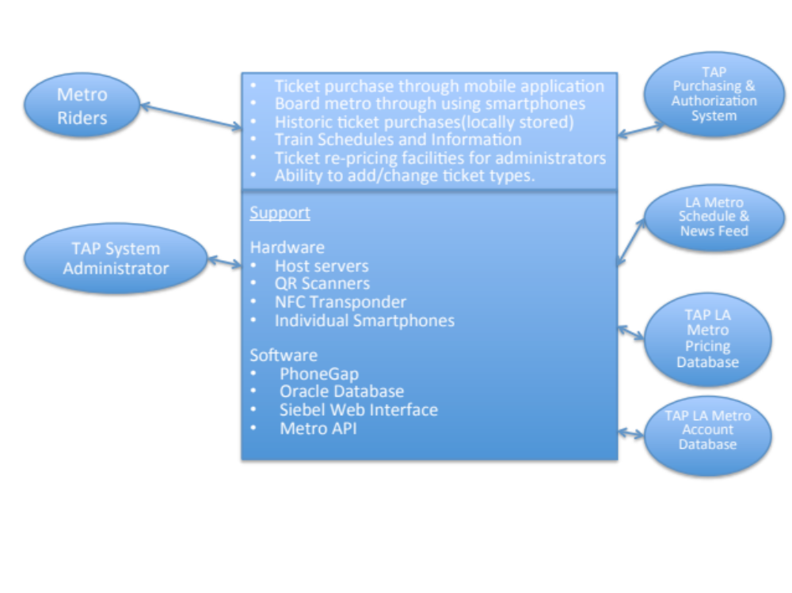

UNRASTURIZED ON SEPARATE PPT.

System Transformation

System Objectives, Constraints and Priorities

Capability Goals
Capability Goals | Priority Level
OC-1 Cross-platform Compatible: The application is compatible with iOS, Android and Windows Phone | Must have
OC-2 Account Creation: The application is able to create new rider accounts, update information, and log in users using existing information. | Must have
OC-3 Usage: The application allows metro riders to board trains via NFC or QR code technology. | Must have
OC-4 Payments: The application allows metro riders to pay for tickets using a secure payment gateway and will allow metro riders to store credit card information. | Must have
OC-5 Schedules: The application allows metro riders to view train schedules. | Should have
OC-6 Map: The application allows metro riders to view a static map of metro stations. | Should Have
OC-7 Updates: The application allows metro riders to receive updates about train station information and irregular service interruptions. | Should Have
OC-8 Pricing: The administration application will allow metro administrators to change ticket pricing | Should Have
OC-9 Ticket Types: The application will support linking of additional tap accounts for the purpose of allowing dependants to be charged with one QR scan. | Could Have
OC-10 Ticket Display: The application will use GPS services to automatically display tickets for the closest station. | Should Have

Level of Service Goals

Table 1: Level of Service Goals
Level of Service Goals | Priority Level
Reliability of application | Must Have
Usability | Must Have
Security | Must Have
Performance of system | Should Have
Inter-operability | Should Have
Maintainability | Should Have

Organizational Goals
OG-1: Increase convenience for ticket buyers.
OG-2: Decrease cost for LA Metro and ticket buyers.
OG-3: Increase efficiency of public transit system by advancing technologically.

Constraints

CO-1: Align with Current Infrastructure: The new application must complement the existing tap card system, and be implemented with minimal changes to existing infrastructure.
CO-2: Cross Platform Compatibility: The new application must be compatible with major smartphone operating systems(iOS, Android and Windows)
CO-3: Phone Hardware: The application must be compatible with the existing hardware in major smartphones.
CO-4: Database Access: The application must have permissions to access TAP databases containing rider information.

Proposed New Operational Concept
The application will allow metro riders to use their mobile devices to purchase tickets and board trains eliminating the need for physical TAP cards. The new system will act as a complement to the TAP card system; allowing riders to use existing metro facilities if they wish. For those smartphones enabled with NFC, the rider will be able to “tap” their phones instead of their tap cards. For those smartphones not enable with NFC, QR readers will be installed at stations that have turnstiles. For stations that do not have turnstiles, Metro agents will be given a QR reader to verify tickets on the train. The application will allow users to view train schedules along with a map of the stations in the users’ metro system. Users will also receive news updates in case of unusual delays or train cancellations.

Element Relationship Diagram

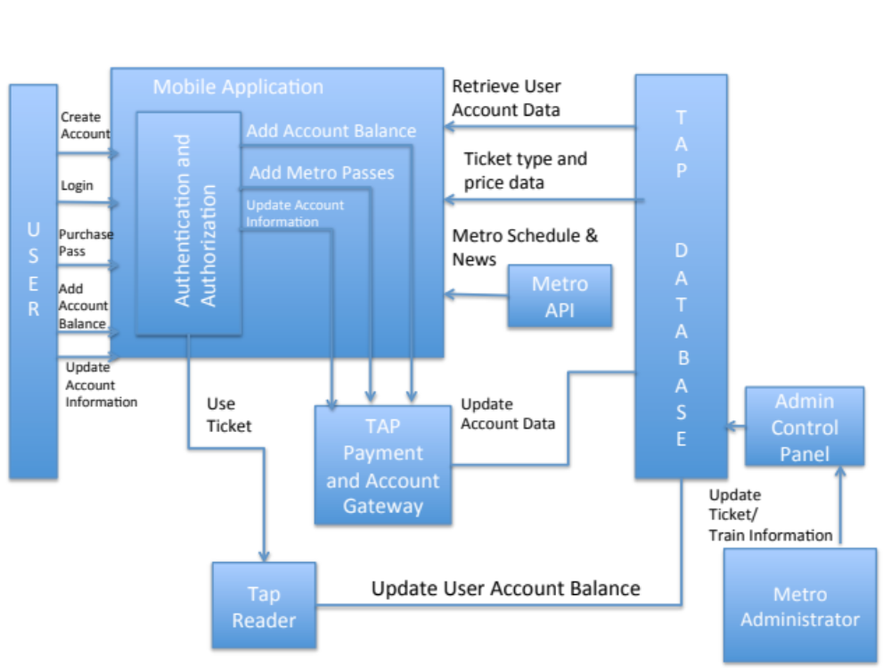

UNRASTURIZED ON PPT

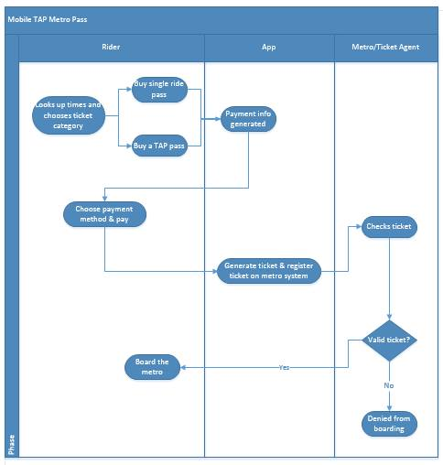
Business Workflows

